- \Operation\Carton sensing\Monitoring, carton erected
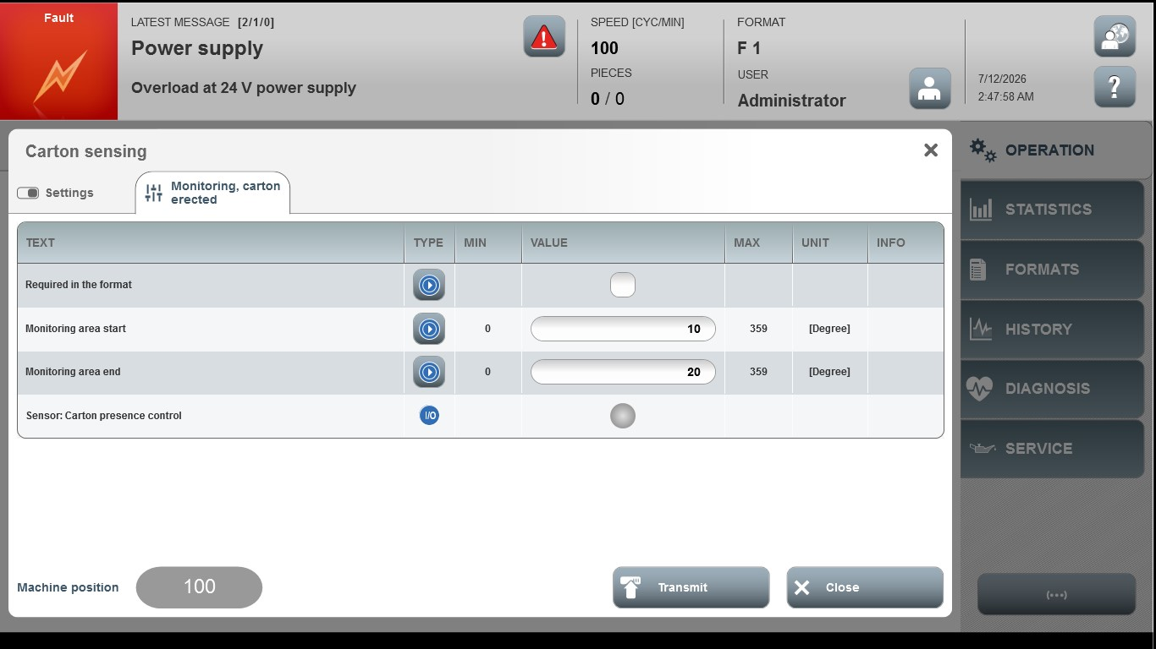

Acceptance criterion | Limits | Pass / Fail: Dev-No. | Date | Initials
Screen matches screenshot | N / A
Monitoring area start | 0…359
Monitoring area end | 0…359

